**DEPARTMENT F0RUM**

Mini project submitted to the particular fulfilment for the award of degree of Bachelor of Mathematics

By

Malathi. M

PG Department of Mathematics (B.Sc)



**MOHAMED SATHAK COLLEGE OF ARTS AND SCIENCE**

(AFFLIATEAD TO THE UNIVERSILTY OF MADRAS)

SHOLINGANALLUR,CHENNAI - 600119

**MOHAMED SATHAK COLLEGE OF ARTS AND SCIENCE**

(AFFLIATEAD TO THE UNIVERSILTY OF MADRAS)

SHOLINGANALLUR,CHENNAI - 600119



BONAFIDE CERTIFICATE

PG DEPARTMENT OF MATHEMATICS (B.Sc)

Certified that this report title “Department Forums” is a bonafide record of the project work done by Malathi.M

Head of the department Lecturer-in-charge

Internal examiner External examiner

**DECLARATION BY THE DEPARTMENT HOD**

**MOHAMED SATHAK COLLEGE OF ARTS AND SCIENCE**

(Affiliated to the University of Madras, approved by UGC &AICTE and Reaccredited by NAAC with ‘B’ Grade)

Sholinganallur, Chennai – 600119



### This is to certify that the Project report entitled “ A COMPREHENSIVE ANALYSIS OF FINANCIAL PERFORMANCE : INSIGHTS FROM A LEADING BANK” is being carried out Student Malathi.M in partial fulfillment of the requirements for the degree of BACHELOR OF MATHEMATICS, University of Madras, Chennai, in during the year of December 2022-March 2023

Signature of the HOD

*A Comprehensive Analysis Of Financial Performance: Insights From A Leading Banks*

**A COMPREHENSIVE ANALYSIS OF INSIGHTS FROM A LEADING BANKS**

### Define Problem / Problem Understanding

### Data Collection & Extraction From Database

### Data Preparation

### Data Visualization

### Dashboard

### Story

### Performance Testing

### Web Integration

### Project Demonstration & Documentation

### Project Description:

### The banking industry world-wide is being transformed. The global forces for change include technological innovation; the deregulation of financial services at the national level and opening-up to international competition; and - equally important - changes in corporate behavior, such as growing disintermediation and increased emphasis on shareholder value. In addition, recent banking crises in Asia and Latin America have accentuated these pressures. The banking industries in central Europe and Latin America have also been transformed as a result of privatizations of state-owned banks that had dominated their banking systems in the past. In this project we are trying to analysis the bank related data and able to extract some insights from the data using Business Intelligence tools. To Extract the Insights from the data and put the data in the form of visualizations, Dashboards and Story we employed Tableau tool.

### Define Problem / Problem Understanding:

### In this milestone, We will go through the problem understanding.

### Specify The Business Problem :

### The banking industry world-wide is being transformed. The global forces for change include technological innovation; the deregulation of financial services at the national level and opening-up to international competition; and - equally important - changes in corporate behavior, such as growing disintermediation and increased emphasis on shareholder value. In addition, recent banking crises in Asia and Latin America have accentuated these pressures. The banking industries in central Europe and Latin America have also been transformed as a result of privatizations of state-owned banks that had dominated their banking systems in the past. In this project we are trying to analysis the bank related data and able to extract some insights from the data using Business Intelligence tools. To Extract the Insights from the data and put the data in the form of visualizations, Dashboards and Story we employed Tableau tool.

### Business Requirements:

### The business requirements for analyzing the performance and efficiency of banks  in world include identifying KPIs, comparing performance across different countries and states, identifying patterns and trends over time, identifying affecting factors, creating interactive dashboards and reports, identifying areas for improvement, making data-driven decisions, comparing to the industry average and creating forecasting models for future performance. The ultimate goal is to gain insights and improve performance through data visualization techniques.

### Literature Survey:

### A literature survey for the financial analysis of banks would involve researching and reviewing previous studies, articles, and reports on the topic. This could include information on the methods and techniques used for financial analysis of banks, as well as the results and conclusions of these studies. Some potential areas of focus for a literature survey on financial analysis of banks could include:

### Ratio analysis, which involves comparing different financial metrics (such as return on assets, return on equity, etc.) to assess a bank's performance and compare it to industry averages or other benchmarks.

### . Stress testing, which involves simulating adverse economic scenarios to evaluate a bank's ability to withstand financial shocks.

### Risk management, which involves identifying, assessing, and mitigating the various risks facing a bank, such as credit risk, market risk, and operational risk.

### Basel III, which is a set of international regulatory standards for banks that includes measures for capital adequacy, liquidity, and leverage

### Social Or Business Impact:

### Social Impact:

### Financial analysis of banks can have a significant social impact by identifying areas where the bank's operations or lending practices may be causing harm to vulnerable communities or perpetuating inequality. For example, a financial analysis might reveal that a bank is heavily invested in fossil fuel companies, contributing to climate change, or that the bank is disproportionately denying loans to minority-owned businesses, perpetuating economic discrimination.

### Business Model/Impact:

### Financial analysis of banks can have a significant impact on the business operations of the bank itself and its competitors. For example, a financial analysis can help the bank identify areas where it is underperforming compared to its peers, such as in terms of profitability or asset quality. This information can then be used to develop strategies for improving the bank's performance, such as by reducing costs, increasing revenue, or improving risk management practices.

### Data Collection & Extraction From Database:

### Data collection is the process of gathering and measuring information on variables of interest, in an established systematic fashion that enables one to answer stated research questions, test hypotheses, evaluate outcomes and generate insights from the data.

### Downloading The Dataset:

|  |  |  |  |  |
| --- | --- | --- | --- | --- |
| Rank | Bank | country | total_assets_us_b | balance_sheet |
| 1 | Industrial & Commercial Bank of China | China | 4,005.58 | 2017-12-31 |
| 2 | China Construction Bank Corp | China | 3,397.13 | 2017-12-31 |
| 3 | Agricultural Bank of China | China | 3,232.68 | 2017-12-31 |
| 4 | Bank of China | China | 2,989.16 | 2017-12-31 |
| 5 | Mitsubishi UFJ Financial Group | Japan | 2,773.82 | 2017-12-31 |
| 6 | JPMorgan Chase & Co | USA | 2,533.60 | 2017-12-31 |
| 7 | HSBC Holdings | UK | 2,521.77 | 2017-12-31 |
| 8 | BNP Paribas | France | 2,348.11 | 2017-12-31 |
| 9 | Bank of America | USA | 2,281.23 | 2017-12-31 |
| 10 | China Development Bank | China | 2,201.86 | 2016-12-31 |
| 11 | Credit Agricole Group | France | 2,112.04 | 2017-12-31 |
| 12 | Wells Fargo | USA | 1,951.76 | 2017-12-31 |
| 13 | Japan Post Bank | Japan | 1,873.50 | 2017-12-31 |
| 14 | Mizuho Financial Group | Japan | 1,850.10 | 2017-12-31 |
| 15 | Sumitomo Mitsui Financial Group | Japan | 1,847.47 | 2017-12-31 |
| 16 | Citigroup Inc | USA | 1,843.06 | 2017-12-31 |
| 17 | Deutsche Bank | Germany | 1,766.85 | 2017-12-31 |
| 18 | Banco Santander | Spain | 1,730.08 | 2017-12-31 |
| 19 | Barclays PLC | UK | 1,528.89 | 2017-12-31 |
| 20 | Societe Generale | France | 1,527.43 | 2017-12-31 |
| 21 | Groupe BPCE | France | 1,509.13 | 2017-12-31 |
| 22 | Bank of Communications | China | 1,387.79 | 2017-12-31 |
| 23 | Postal Savings Bank of China | China | 1,383.85 | 2017-12-31 |
| 24 | Lloyds Banking Group | UK | 1,095.64 | 2017-12-31 |
| 25 | Royal Bank of Canada | Canada | 1,028.72 | 2017-12-31 |
| 26 | ING Groep NV | Netherlands | 1,013.65 | 2017-12-31 |
| 27 | Toronto-Dominion Bank | Canada | 1,006.98 | 2017-12-31 |
| 28 | Norinchukin Bank | Japan | 1,006.70 | 2017-12-31 |
| 29 | UniCredit S.p.A. | Italy | 1,002.36 | 2017-12-31 |
| 30 | Royal Bank of Scotland Group | UK | 995.729 | 2017-12-31 |
| 31 | Industrial Bank Co. Ltd | China | 985.646 | 2017-12-31 |
| 32 | China Merchants Bank | China | 966.117 | 2017-12-31 |
| 33 | Intesa Sanpaolo | Italy | 954.531 | 2017-12-31 |
| 34 | Credit Mutuel | France | 950.531 | 2016-12-31 |
| 35 | UBS Group AG | Switzerland | 937.802 | 2017-12-31 |
| 36 | Shanghai Pudong Development Bank | China | 942.777 | 2017-12-31 |
| 37 | Goldman Sachs Group | USA | 916.787 | 2017-12-31 |
| 38 | Agricultural Development Bank of China | China | 873.419 | 2017-06-30 |
| 39 | China Minsheng Banking Corp | China | 859.407 | 2017-09-30 |
| 40 | Morgan Stanley | USA | 851.733 | 2017-12-31 |
| 41 | China CITIC Bank Corp | China | 832.996 | 2017-09-30 |
| 42 | BBVA | Spain | 826.597 | 2017-12-31 |
| 43 | Credit Suisse Group | Switzerland | 815.587 | 2017-12-31 |
| 44 | Bank of Nova Scotia | Canada | 754.509 | 2017-12-31 |
| 45 | Commonwealth Bank of Australia | Australia | 750.775 | 2017-12-31 |
| 46 | Rabobank Group | Netherlands | 722.301 | 2017-12-31 |
| 47 | Australia & New Zealand Banking Group | Australia | 700.352 | 2017-09-30 |
| 48 | Nordea | Sweden | 695.795 | 2017-12-31 |
| 49 | European Investment Bank | Luxembourg | 686.653 | 2016-12-31 |
| 50 | Westpac Banking Corp | Australia | 664.878 | 2017-09-30 |
| 51 | Standard Chartered Plc | UK | 663.501 | 2017-12-31 |
| 52 | National Australia Bank | Australia | 615.516 | 2017-09-30 |
| 53 | China Everbright Bank | China | 627.737 | 2017-12-31 |
| 54 | DZ Bank AG | Germany | 605.64 | 2017-12-31 |
| 55 | Bank of Montreal | Canada | 578.53 | 2017-12-31 |
| 56 | Sumitomo Mitsui Trust Holdings | Japan | 569.949 | 2017-12-31 |
| 57 | Danske Bank | Denmark | 569.335 | 2017-12-31 |
| 58 | KfW Group | Germany | 565.392 | 2017-12-31 |
| 59 | Commerzbank | Germany | 541.434 | 2017-12-31 |
| 60 | State Bank of India | India | 534.903 | 2017-12-31 |
| 61 | Cassa Depositi e Prestiti (CDP) | Italy | 496.74 | 2017-06-30 |
| 62 | The Export-Import Bank of China (Eximbank) | China | 491.888 | 2016-12-31 |
| 63 | Canadian Imperial Bank of Commerce | Canada | 483.791 | 2017-12-31 |
| 64 | Ping An Bank | China | 481.75 | 2017-09-30 |
| 65 | ABN AMRO Group NV | Netherlands | 470.965 | 2017-12-31 |
| 66 | Sberbank of Russia | Russia | 470.181 | 2017-12-31 |
| 67 | U.S. Bancorp | USA | 462.04 | 2017-12-31 |
| 68 | CaixaBank | Spain | 459.005 | 2017-12-31 |
| 69 | Itau Unibanco Holding SA | Brazil | 437.41 | 2017-12-31 |
| 70 | Resona Holdings | Japan | 434.653 | 2017-12-31 |
| 71 | Banco do Brasil SA | Brazil | 413.147 | 2017-12-31 |
| 72 | KB Financial Group | South Korea | 409.01 | 2017-12-31 |
| 73 | Shinhan Financial Group | South Korea | 399.197 | 2017-12-31 |
| 74 | Nomura Holdings | Japan | 394.791 | 2017-12-31 |
| 75 | DBS Group Holdings | Singapore | 387.252 | 2017-12-31 |
| 76 | Caixa Economica Federal | Brazil | 383.261 | 2017-09-30 |
| 77 | PNC Financial Services Group | USA | 380.768 | 2017-12-31 |
| 78 | Hua Xia Bank | China | 375.543 | 2017-09-30 |
| 79 | Bank of New York Mellon Corp | USA | 371.758 | 2017-12-31 |
| 80 | Shinkin Central Bank (SCB) | Japan | 371.313 | 2017-12-31 |
| 81 | Capital One Financial Corporation | USA | 365.693 | 2017-12-31 |
| 82 | Banco Bradesco SA | Brazil | 365.493 | 2017-12-31 |
| 83 | KBC Group NV | Belgium | 350.186 | 2017-12-31 |
| 84 | Bank of Beijing | China | 349.354 | 2017-09-30 |
| 85 | Oversea-Chinese Banking Corp (OCBC) | Singapore | 340.297 | 2017-12-31 |
| 86 | Hana Financial Group | South Korea | 337.191 | 2017-12-31 |
| 87 | Svenska Handelsbanken | Sweden | 336.691 | 2017-12-31 |
| 88 | NongHyup Financial Group | South Korea | 333.156 | 2017-06-30 |
| 89 | Woori Bank | South Korea | 332.893 | 2017-12-31 |
| 90 | DnB ASA | Norway | 328.267 | 2017-12-31 |
| 91 | China Guangfa Bank (CGB) | China | 314.401 | 2016-12-31 |
| 92 | Skandinaviska Enskilda Banken | Sweden | 311.457 | 2017-12-31 |
| 93 | Nationwide Building Society | UK | 306.963 | 2017-09-30 |
| 94 | Cathay Financial Holding | Taiwan | 293.554 | 2017-09-30 |
| 95 | Landesbank Baden-Wurttemberg | Germany | 285.092 | 2017-12-31 |
| 96 | La Banque Postale | France | 277.278 | 2017-12-31 |
| 97 | Bank of Shanghai | China | 270.242 | 2017-09-30 |
| 98 | Swedbank | Sweden | 269.238 | 2017-12-31 |
| 99 | United Overseas Bank (UOB) | Singapore | 268.23 | 2017-12-31 |
| 100 | Bank of Jiangsu | China | 266.798 | 2017-09-30 |
| 101 | Banco Sabadell | Spain | 265.145 | 2017-12-31 |
| 102 | Bayerische Landesbank | Germany | 264.668 | 2017-06-30 |
| 103 | Erste Group Bank AG | Austria | 264.319 | 2017-12-31 |
| 104 | Brazilian Development Bank (BNDES) | Brazil | 262.087 | 2017-09-30 |
| 105 | Industrial Bank of Korea | South Korea | 256.641 | 2017-12-31 |
| 106 | Bankia | Spain | 256.261 | 2017-12-31 |
| 107 | Charles Schwab Corp | USA | 243.274 | 2017-12-31 |
| 108 | Dexia | Belgium | 238.847 | 2017-06-30 |
| 109 | State Street Corp | USA | 238.425 | 2017-12-31 |
| 110 | Raiffeisen Schweiz | Switzerland | 233.677 | 2017-06-30 |
| 111 | Nykredit Group | Denmark | 229.493 | 2017-12-31 |
| 112 | Fubon Financial Holding | Taiwan | 225.911 | 2017-09-30 |
| 113 | VTB Bank | Russia | 225.604 | 2017-12-31 |
| 114 | China ZheShang Bank (CZBank) | China | 223.148 | 2017-06-30 |
| 115 | BB&T Corporation | USA | 221.642 | 2017-12-31 |
| 116 | Qatar National Bank | Qatar | 221.18 | 2017-12-31 |
| 117 | National Bank of Canada | Canada | 208.408 | 2017-12-31 |
| 118 | Suntrust Banks | USA | 205.962 | 2017-12-31 |
| 119 | Korea Development Bank | South Korea | 205.145 | 2016-12-31 |
| 120 | Belfius | Belgium | 201.192 | 2017-12-31 |

### Understand The Data:

### Data contains all the meta information regarding the columns described in the CSV files

### Column Description Of The Dataset:

### bank: Name of the bank

### Country: In which country the bank is operating

### Total Assest: Total assets of the banks

### Rank : Rank of the bank among the world

### landmass : Under which continent the bank belongs to

### Storing Data In DB & Perform SQL Operations

Explanation video link:

[https://drive.google.com/file/d/1uUaPt7PE3t-jPk4txwyGsbVDkcXzDwOl/view?usp=sharing](https://drive.google.com/file/d/1uUaPt7PE3t-jPk4txwyGsbVDkcXzDwOl/view?usp=sharing%C2%A0)

### Connect DB With Tableau:

Explanation video link:

<https://drive.google.com/file/d/1SRA3ZmvxodiJSLgAFZaOIDdXSHxxyId4/view?usp=sharing>

### Data Preparation:

### In this milestone, we will go through the data preparation.

### Prepare The Data For Visualization:

### Preparing the data for visualization involves cleaning the data to remove irrelevant or missing data, transforming the data into a format that can be easily visualized, exploring the data to identify patterns and trends, filtering the data to focus on specific subsets of data, preparing the data for visualization software, and ensuring the data is accurate and complete. This process helps to make the data easily understandable and ready for creating visualizations to gain insights into the performance and efficiency.

### Data Visualization:

### Data visualization is the process of creating graphical representations of data to help people understand and explore the information. The goal of data visualization is to make complex data sets more accessible, intuitive, and easier to interpret. By using visual elements such as charts, graphs, and maps, data visualizations can help people quickly identify patterns, trends, and outliers in the data.

### No Of Unique Visualizations:

### The number of unique visualizations that can be created with a given dataset. Some common types of visualizations that can be used to analyze the performance and efficiency of banks include bar charts, line charts, heat maps, scatter plots, pie charts,Maps etc. These visualizations can be used to compare performance, track changes over time, show distribution, and relationships between variables, breakdown of revenue and customer demographics, workload, resource allocation and location of banks.

### Top Banks According Rank And Assets:

### 

### Top Banks According To Country Based On Total Assets:

### Top 10 Countries With Assets Proportion:

### 

### Country With Total Assets Using Funnel Chart In Increasing Order:

### Total Assets Analysis According To Year And Quarter:

### Dashboard:

### A dashboard is a graphical user interface (GUI) that displays information and data in an organized, easy-to-read format. Dashboards are often used to provide real-time monitoring and analysis of data and are typically designed for a specific purpose or use case. Dashboards can be used in a variety of settings, such as business, finance, manufacturing, healthcare, and many other industries. They can be used to track key performance indicators (KPIs), monitor performance metrics, and display data in the form of charts, graphs, and tables.

### Responsive And Design Of Dashboard:

### Once you have created views on different sheets in Tableau, you can pull them into a dashboard.

### 

### Story:

### A data story is a way of presenting data and analysis in a narrative format, intending to make the information more engaging and easier to understand. A data story typically includes a clear introduction that sets the stage and explains the context for the data, a body that presents the data and analysis logically and systematically, and a conclusion that summarizes the key findings and highlights their implications. Data stories can be told using a variety of mediums, such as reports, presentations, interactive visualizations, and videos.

### No Of Scenes Of Story:

### The number of scenes in a storyboard for a data visualization analysis of the performance of banks will depend on the complexity of the analysis and the specific insights that are trying to be conveyed. A storyboard is a visual representation of the data analysis process and it breaks down the analysis into a series of steps or scence

### 

### 

### 

### 

### 

### Performance Testing:

### In this milestone, we will go through the performance testing.

**Amount Of Data Rendered To DB**

1. The amount of data that is rendered to a database depends on the size of the dataset and the capacity of the database to store and retrieve data.
2. Open the MySQL Workbench, go to the database then click to expand the tables, select the table and click on (i) button to get the information related to table such as column
3. count,table rows etc. 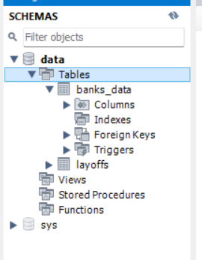

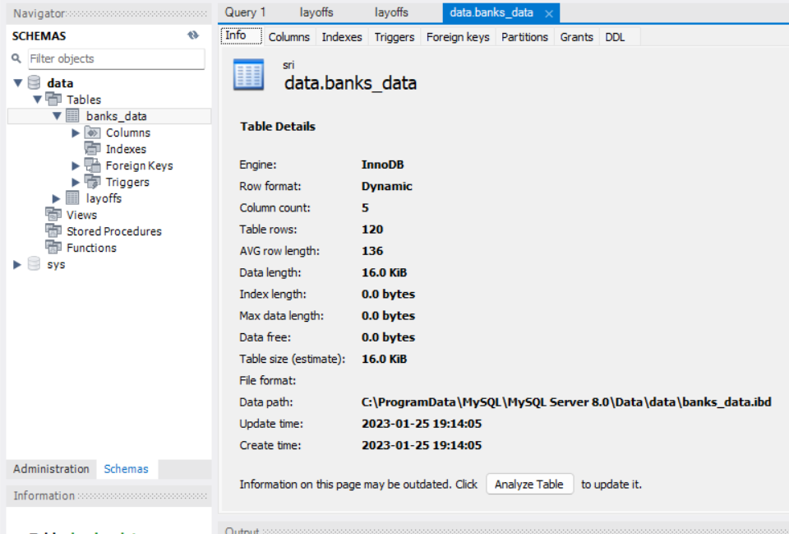

### Utilization Of Data Filters:

### No Of Calculation Fields:

### 

### No Of Visualizations/ Graphs:

### Top banks according rank and assets

### Top banks according to total assets

### Top banks according to country based on total assets

### Top 10 Countries with assets proportion

### Country with total assets using funnel chart in increasing order

### Total assets analysis according to year and quarter

### Web Integration:

### Publishing helps us to track and monitor key performance metrics and to communicate results and progress. help a publisher stay informed, make better decisions, and communicate their performance to others.

### Publishing dashboard and reports to tableau public

### Step 1: Go to Dashboard/story, click on the share button on the top ribbon

### 

**Step 2:** Once you click on connect it will ask you for the tableau public username and password

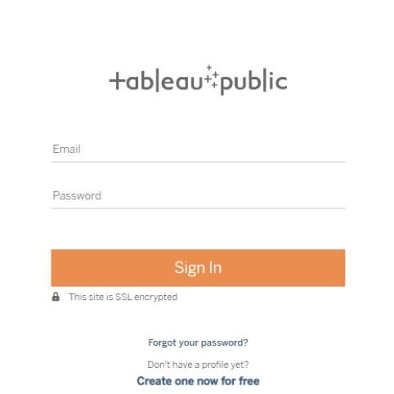

Once you login into your tableau public using the credentials, the particular visualization will be published into the tableau public

Note: While publishing the visualization to the public, the respective sheet will get published when you check on the share option.

### Embed Dashboard & Story With Web Bootstrap:

**Explanation video link:**

<https://drive.google.com/file/d/1UCDtmXj8FI4bgHeNZs2EZFYuJzVF_gwN/view?usp=sharing> 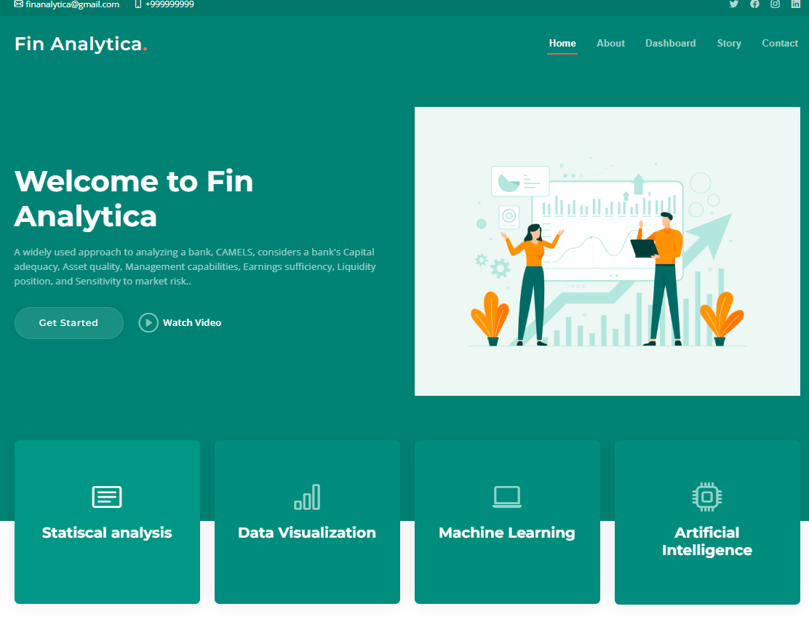

### 

### Project Demonstration & Documentation:

### Projects deliverables to be submitted along with other deliverables

### Record Explanation Video For The Project's End-To-End Solution

### Record explanation Video for the project's end-to-end solution

### Project Documentation-Step By Step Project Development Procedure

### Create document as per the template provided

### 